*Abdallah Tourbah*

*Tino Bou Rada*

*Omar Shatila*

*Hussein Cherri*

**SE phase 3: System and Unit testing**

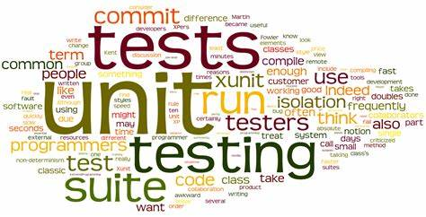

**Introduction:**

Fitness Pro alongside its system AItrainer is the software used to provide data like videos to practice from for their customers to strengthen their bodies. While customers has freedom to chose if he or she likes to get help from real trainer from the app and arrange a meeting.

We initially were focus on mobile app but due to lack of experts in the team we had to go with web application so we changed our focus to web app we used and the platform we used was PHP and HTML as for the database we used MYSQL under phpMyAdmin. After all in this document we will show 4 functions or uses cases to test out of those 4, 2 of them are user use cases and other 2 are admin cases

**User Side Function:**

* Login
* Create account

**Admin Side Functions:**

* Add videos
* Delete videos

**System Implementation:**

We describe now the details of the system , its role, and each component used. The description shows what happens to our system while implementing the code.

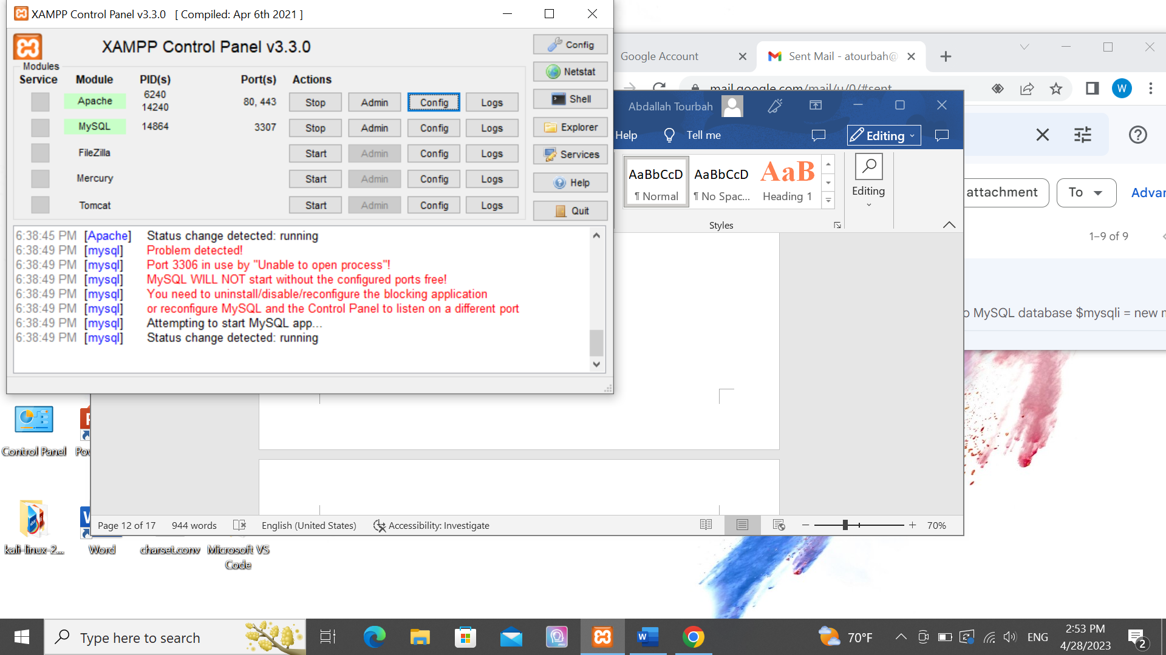

**User Side Function:**

**Logging in:**

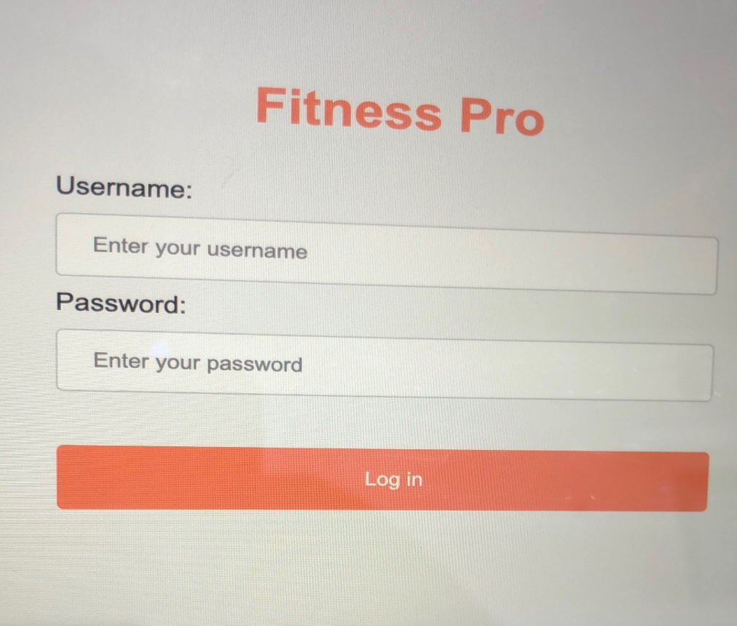

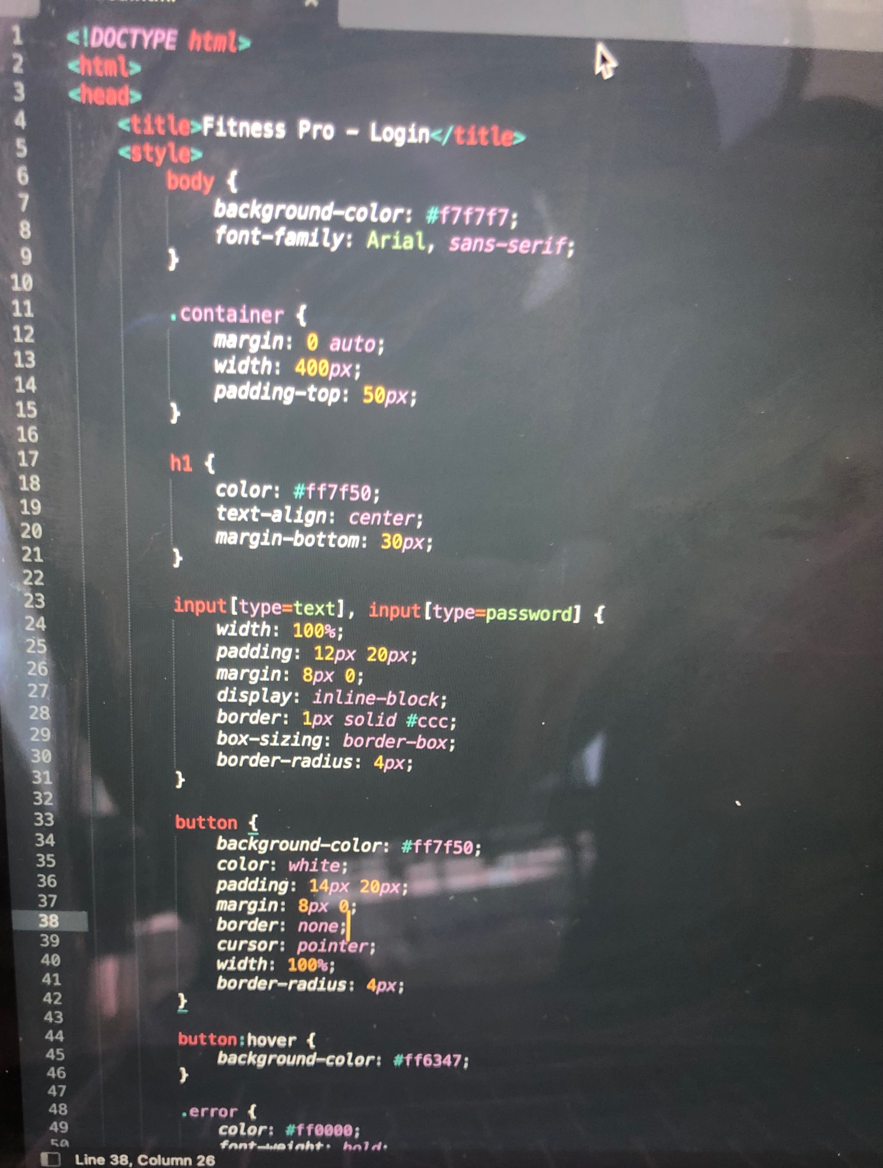

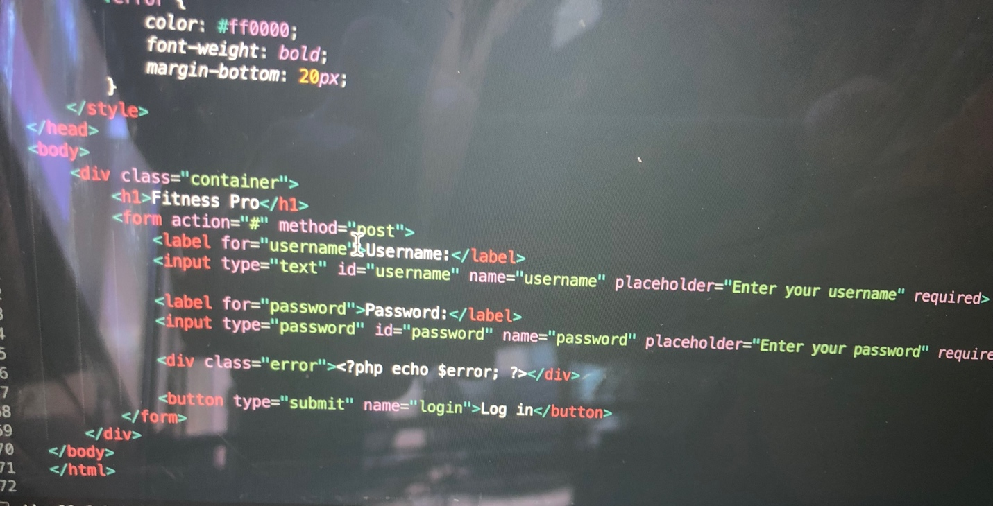

The code above designs a login page by using username and password button letting user type inputs for the system to check whether the username and password from the user exists to allow user to get access. If it happens that data of the user doesn’t exist already we use $error to display error to user. We also used this html code and linked it to another file that links html to SQL from localhost using queries to check if the login username and password exist in the database or not. In the picture below, if username and password are matching there will be a record where num_rows>0 if they don’t match the user will notice error message about username or password incorrect.

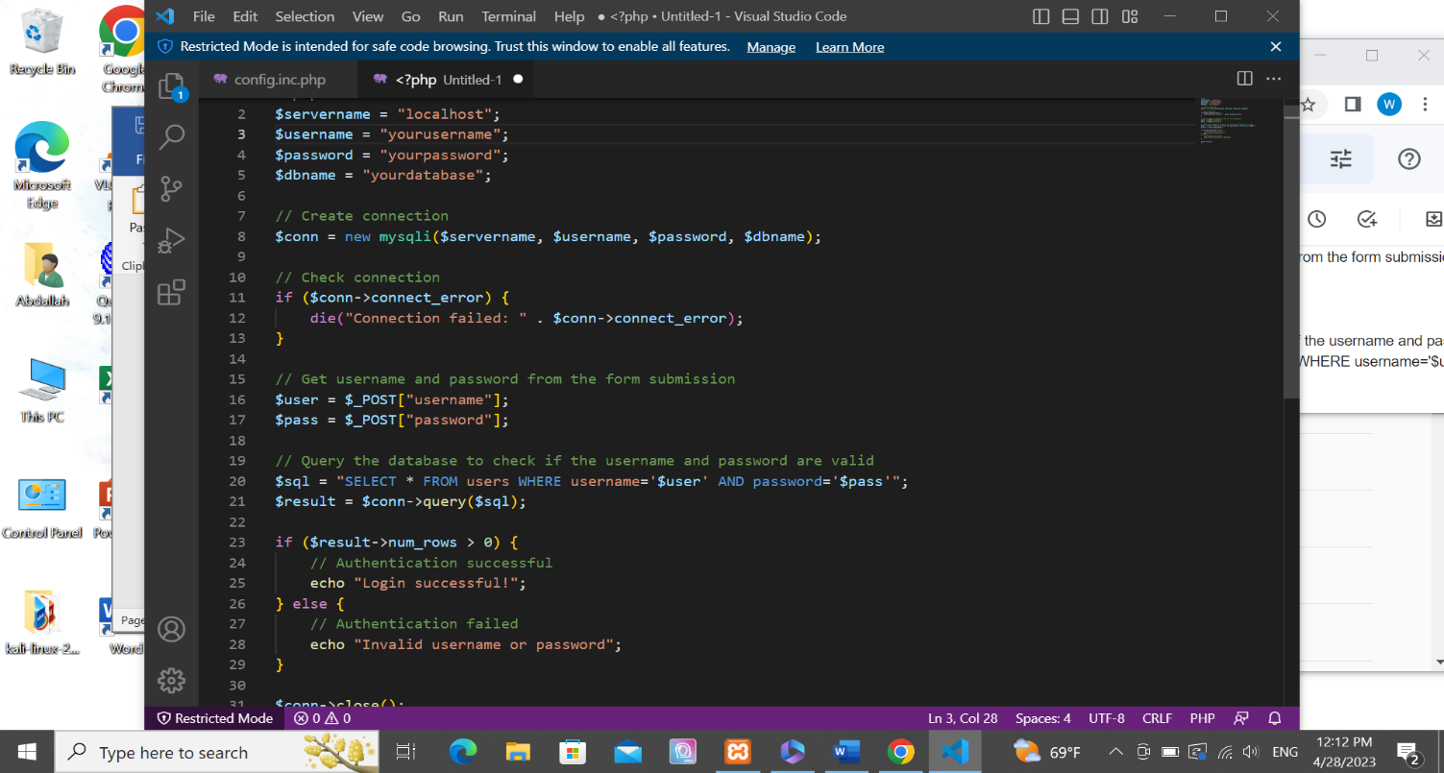

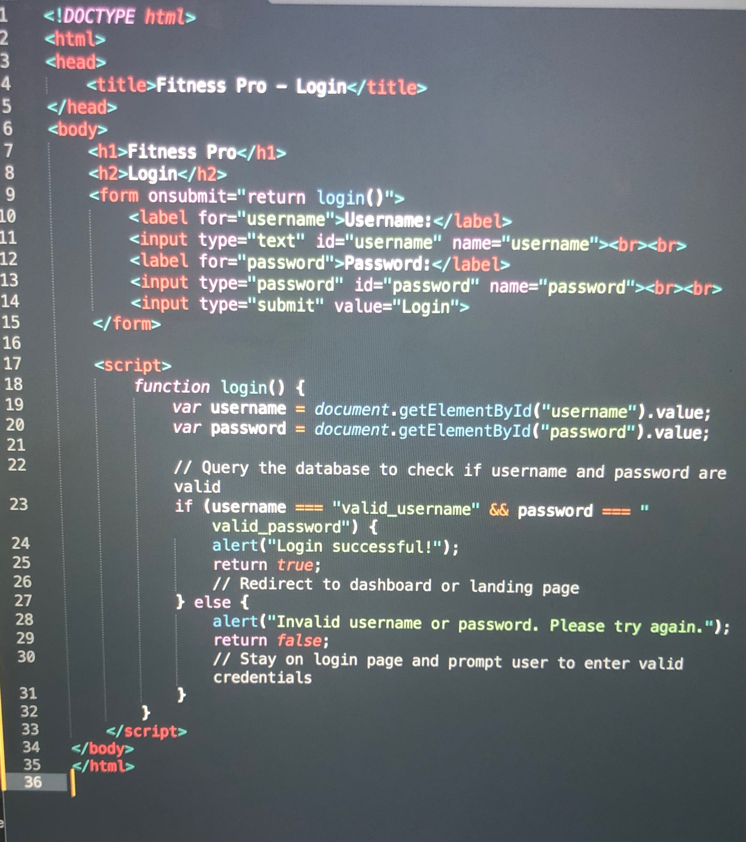

In addition this portion of the code from first file example we can see the login function gets called when the form is submitted. It then grabs the username and password entered by the user and checks if they match the ones in the database (in this case, hard-coded to be "valid_username" and "valid_password"). If they match, an alert message is shown to the user confirming the successful login, and the function returns true to allow the user to proceed to the dashboard or landing page. If they don't match, an alert message is shown prompting the user to enter valid credentials, and the function returns false to prevent the form from submitting and to keep the user on the login page.

**Create account:**

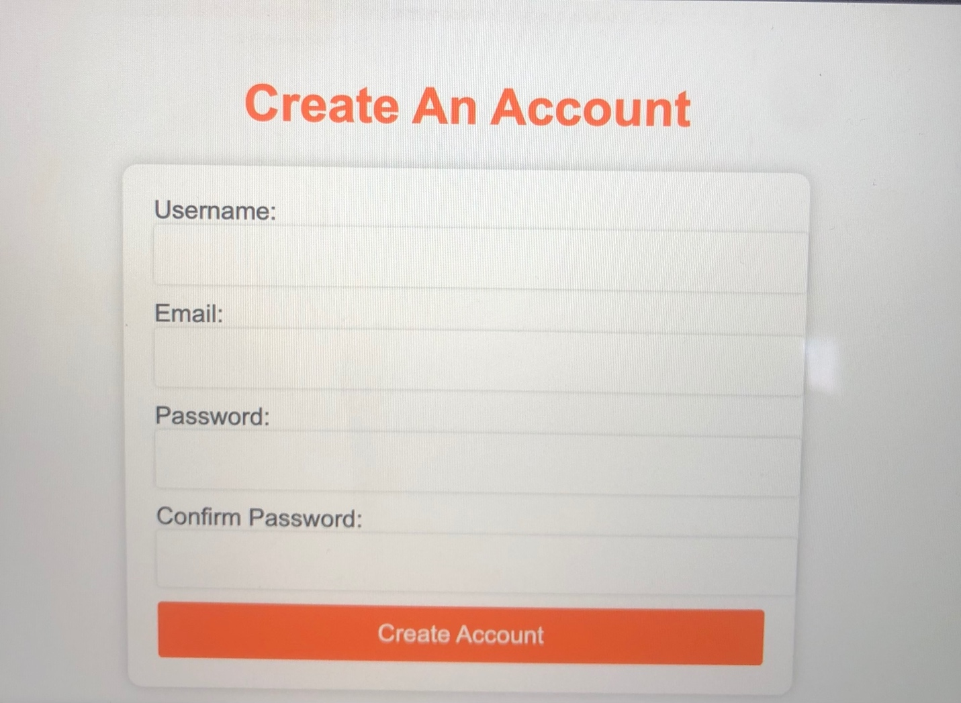

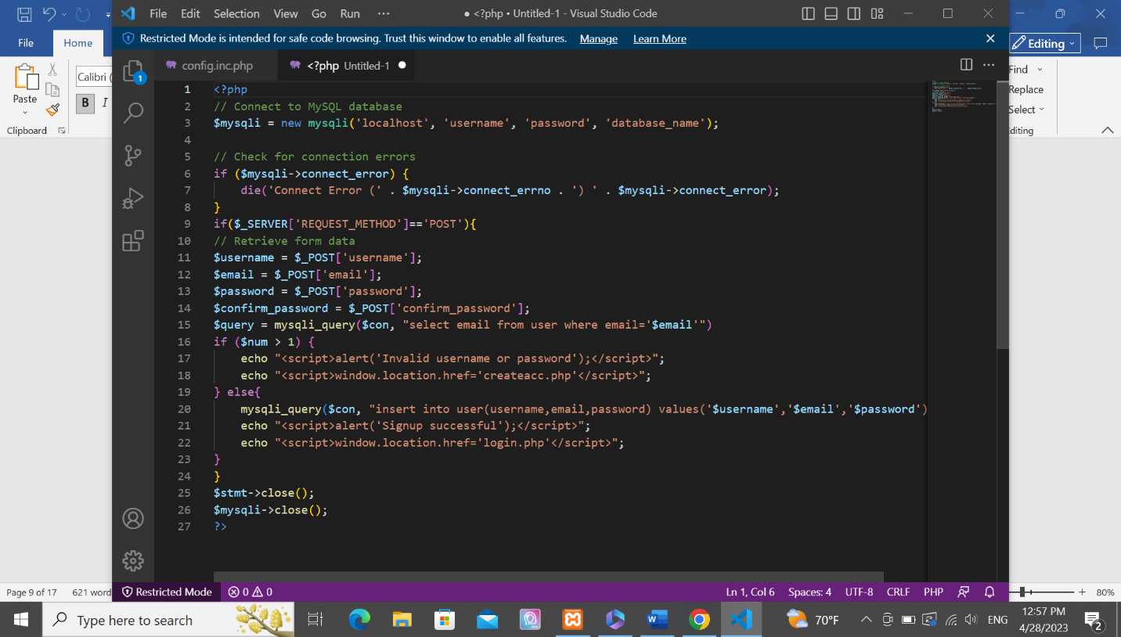

If user submits the form a query will be executed if it doesn’t bypass the uniqueness rule it will saved in the database and just like login now if num>1 it will show an error message if not it will enter the user data in the database.

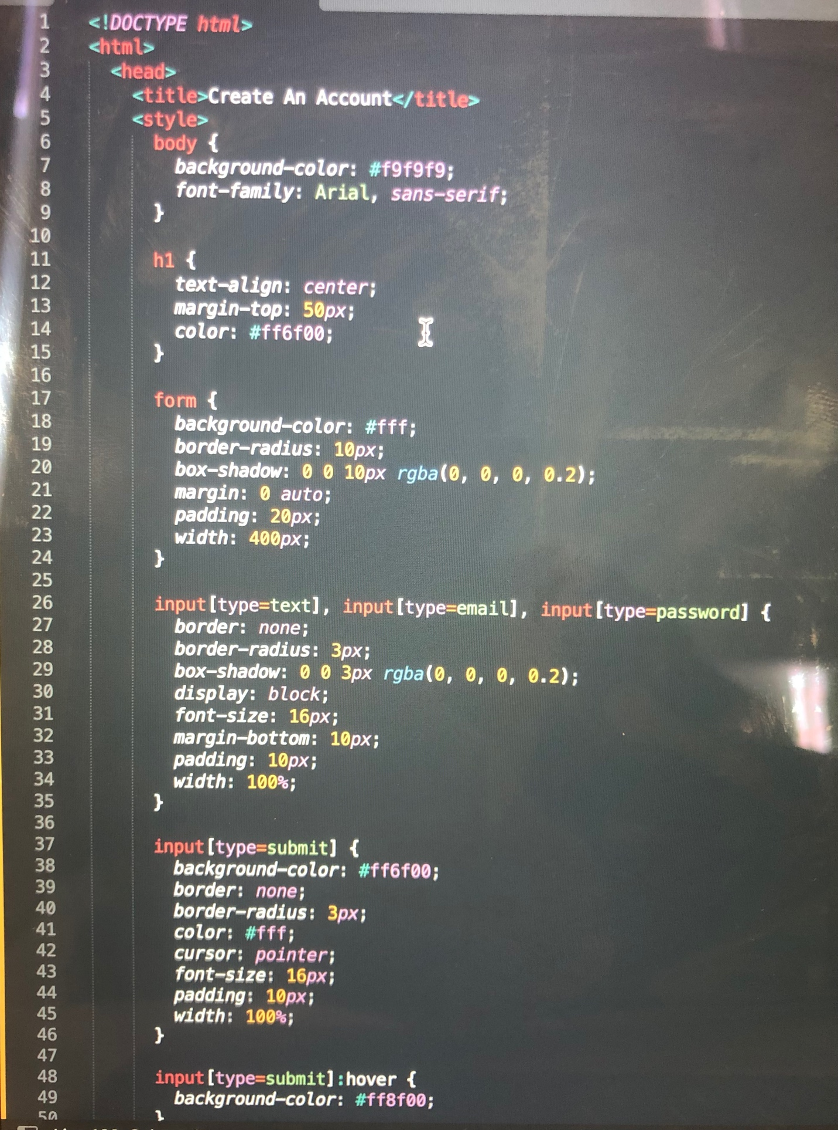

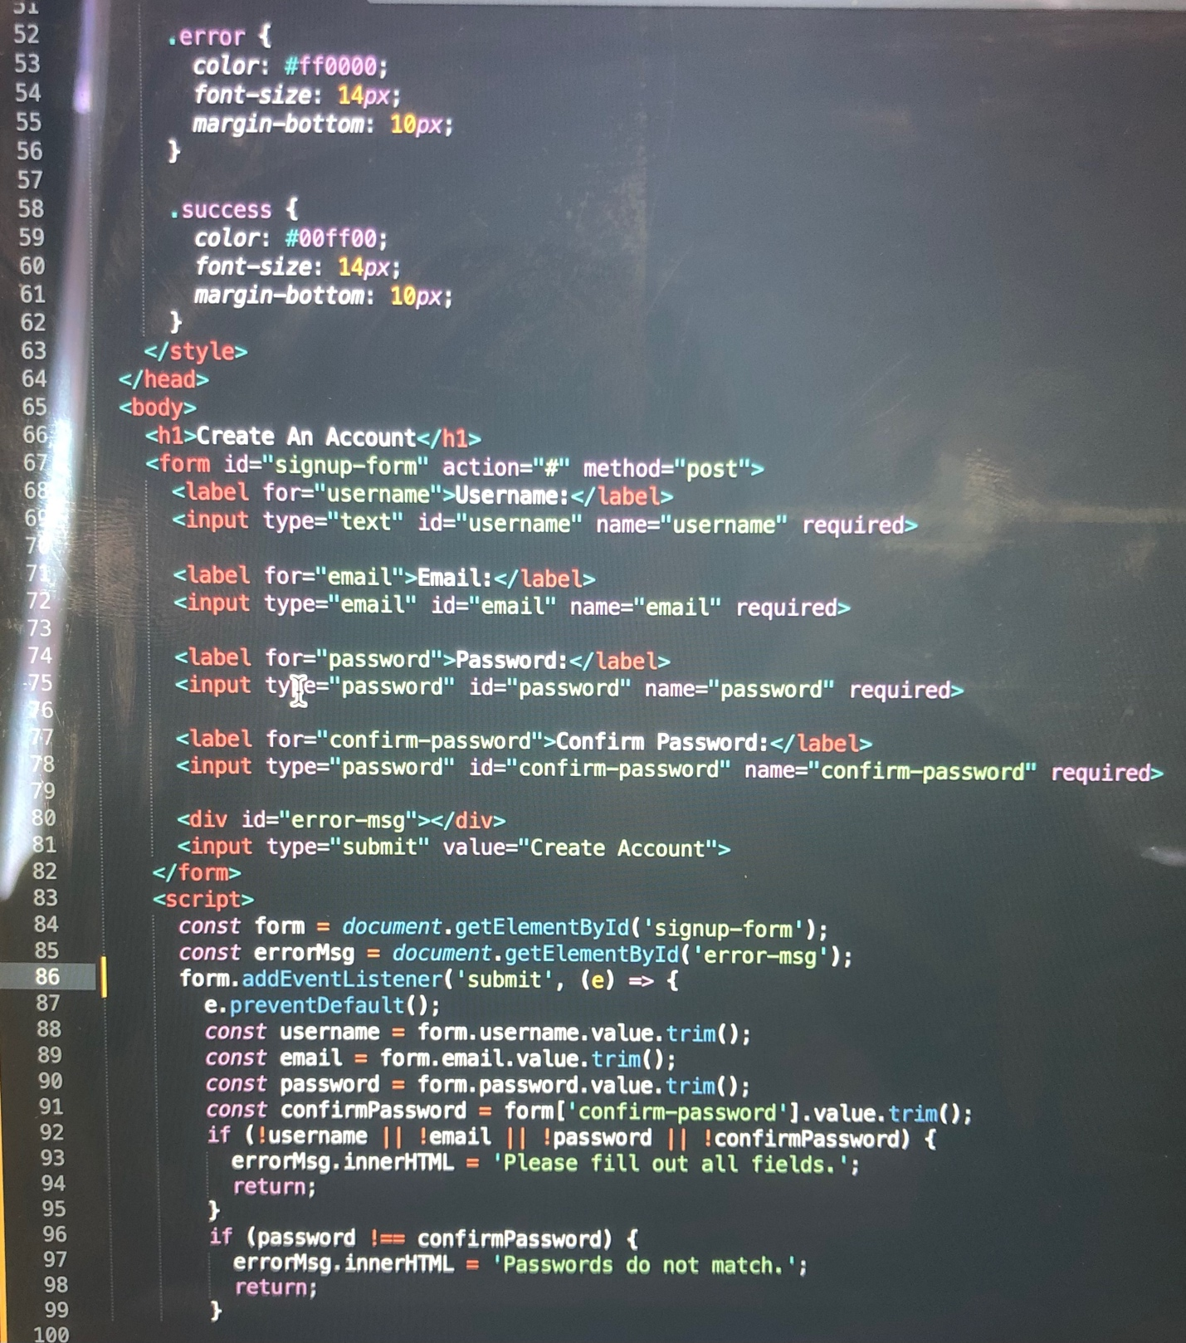

This code will create a sign-up webpage with an orange background color and white foreground color. The title of the page will be "Create An Account". The page will have a form with four input fields: username, email, password, and confirm password, and a button to create an account. The form will have a POST method and will submit to a PHP script called "query.php" when the user clicks the "Create Account" button. The password and confirm password fields will have a minimum length of 6 characters and will be required fields. And we check if password and confirm password values entered by user matches.

**Admin Functions:**

**Delete Video:**

Before deleting:

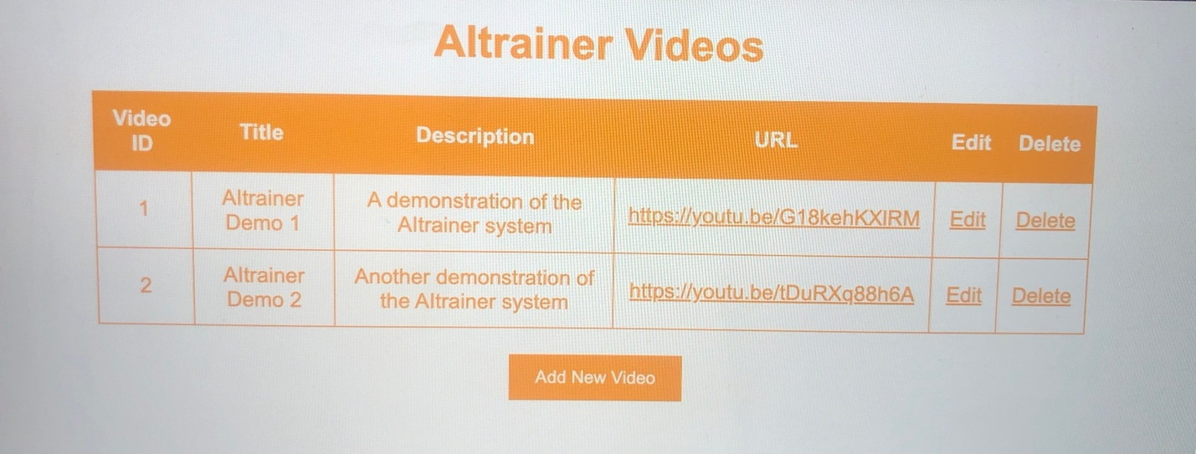

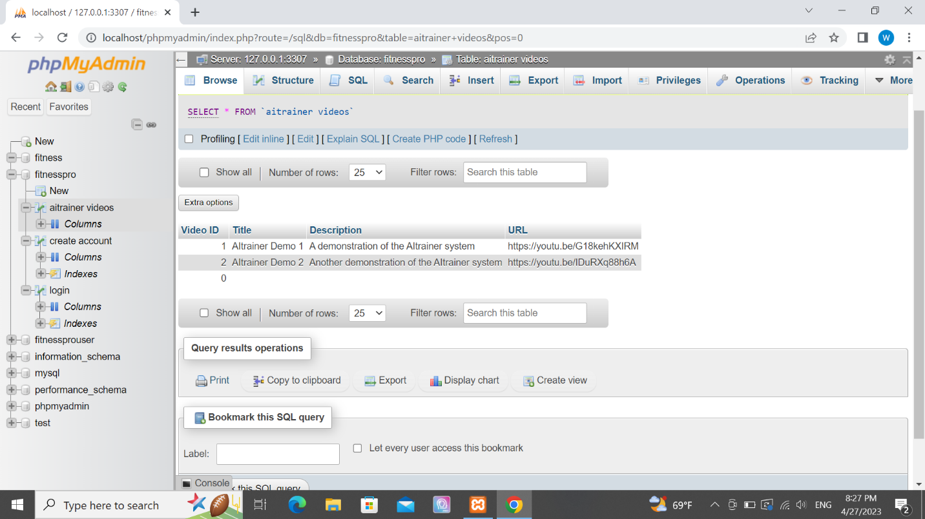

After deleting a video:

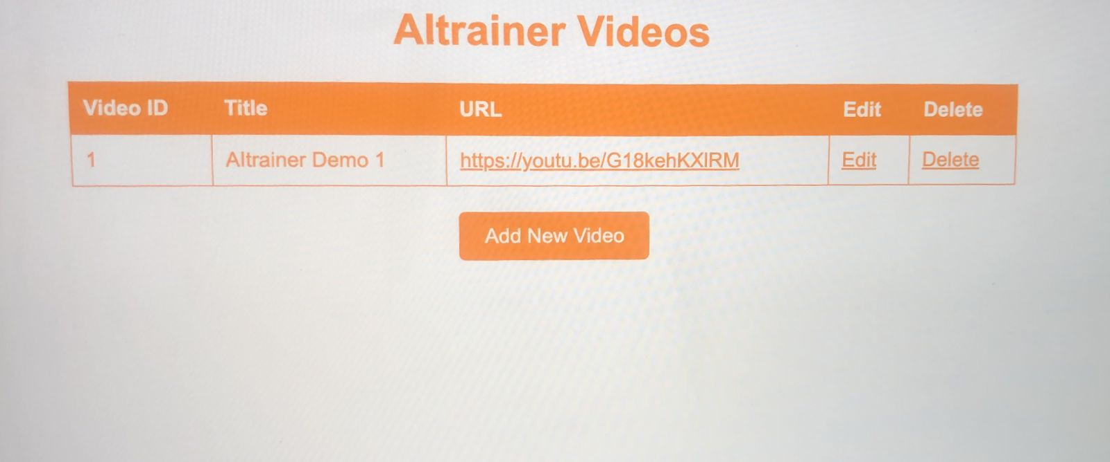

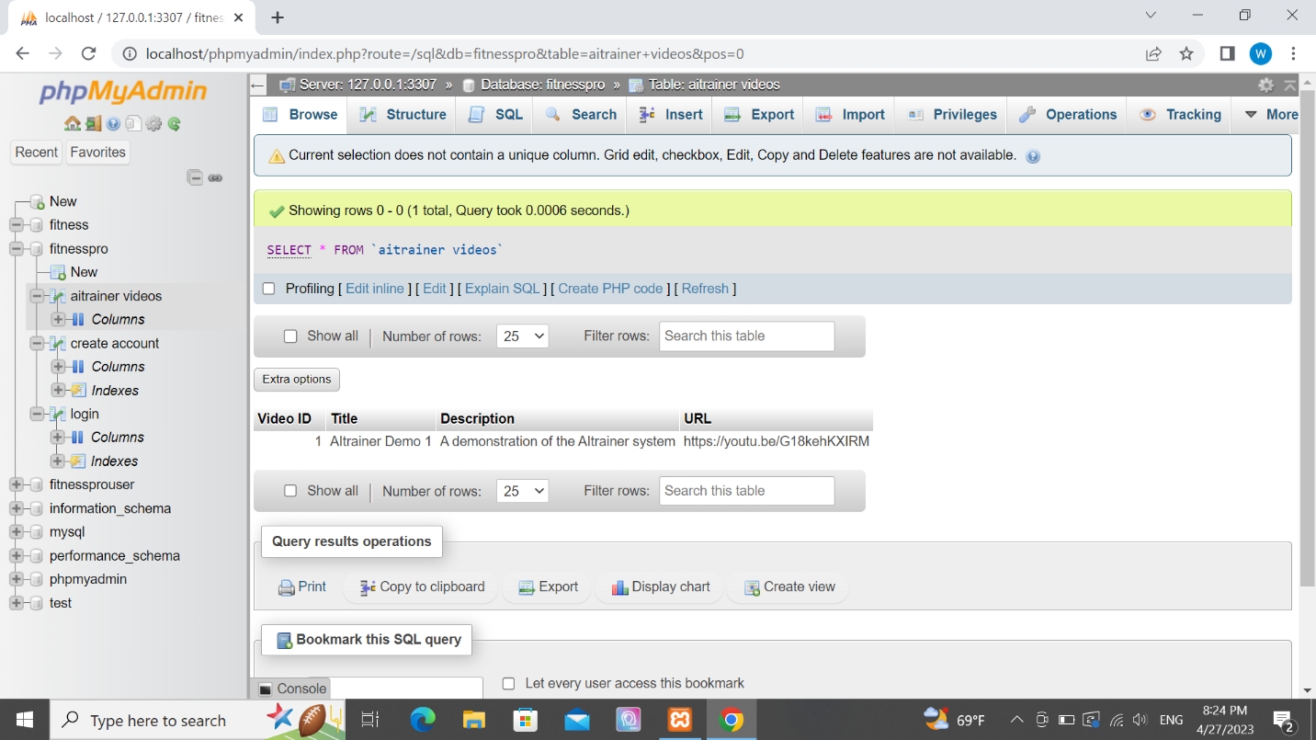

It is clear that the database shows the change int the website that was done once video has been deleted.

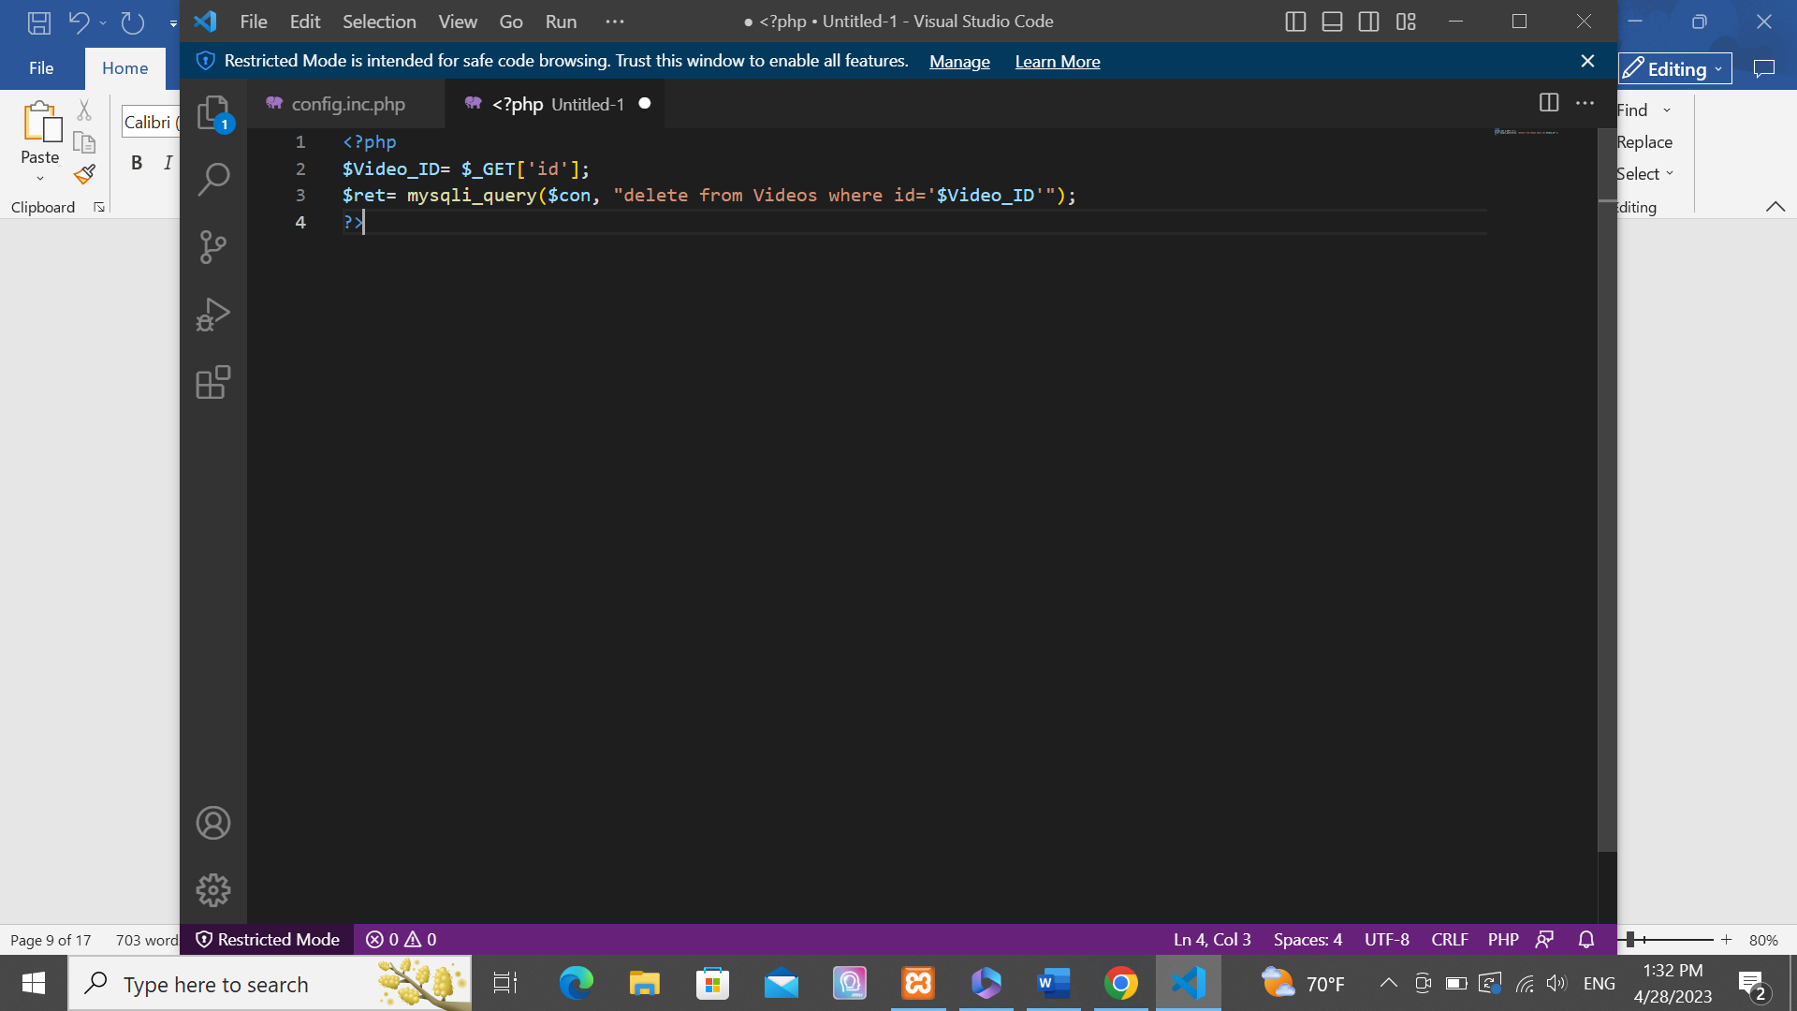

When the admin clicks on the video to be deleted the id will be echoed by using “location.replace(document.referrer)”. so the deletion will be based on the video id since it is unique.

**Adding video:**

Before adding:





After adding:

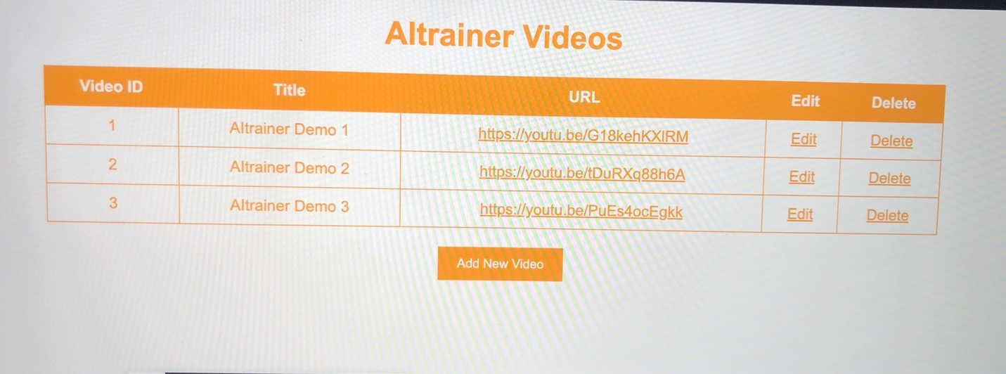

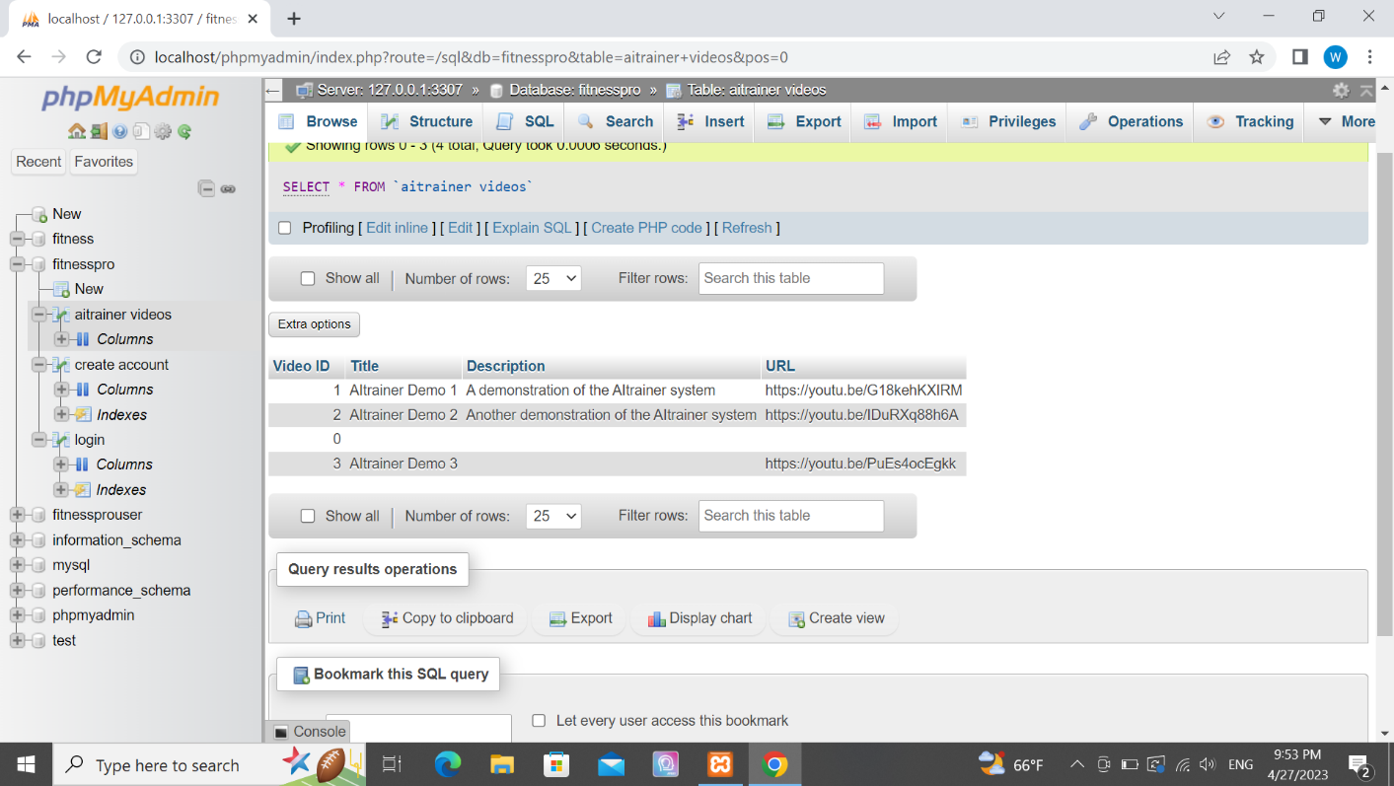

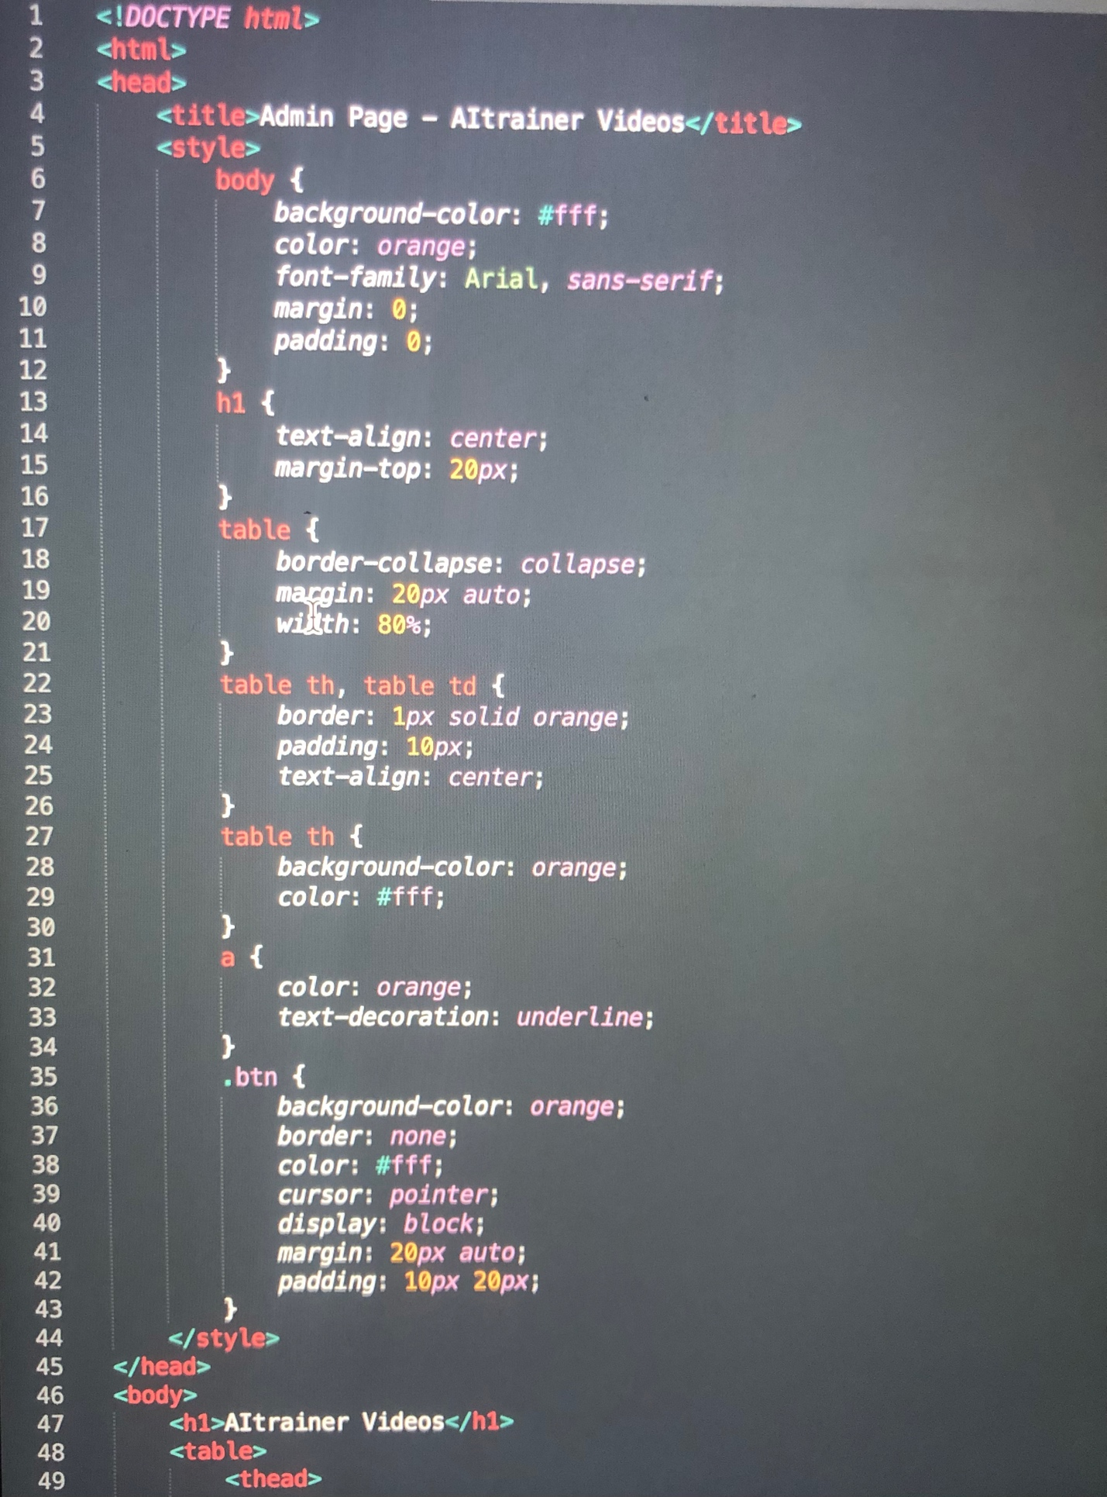

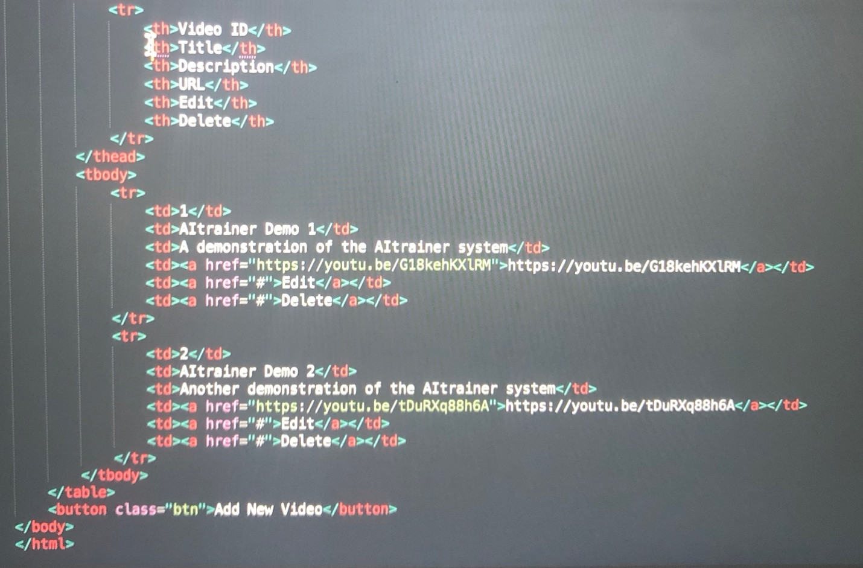

The code above creates a sample HTML webpage for the admin of the system with a white background and orange text color. It includes a table for adding or deleting videos of "AItrainer" that exist in the database, with options to edit and delete and add underlined like a link page. It also includes two sample videos using the URLs you provided, and a button to add a new video. (it is the same for add and delete function).

N.B: We have used xampp after downloading Apache and MySQL successfully to access from the localhost in admin mode using the following ports. We also changed in html code from alert to popup since it looks better

**Unit Testing:**

**Logging In:**

**1)login successful**

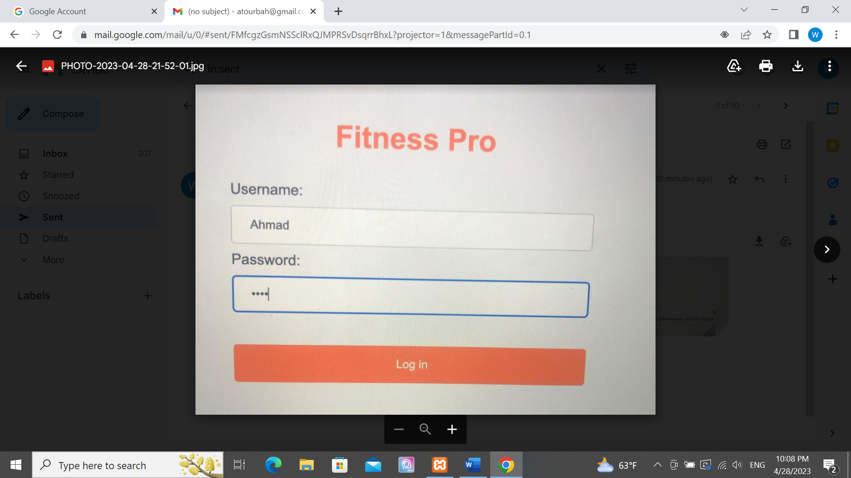

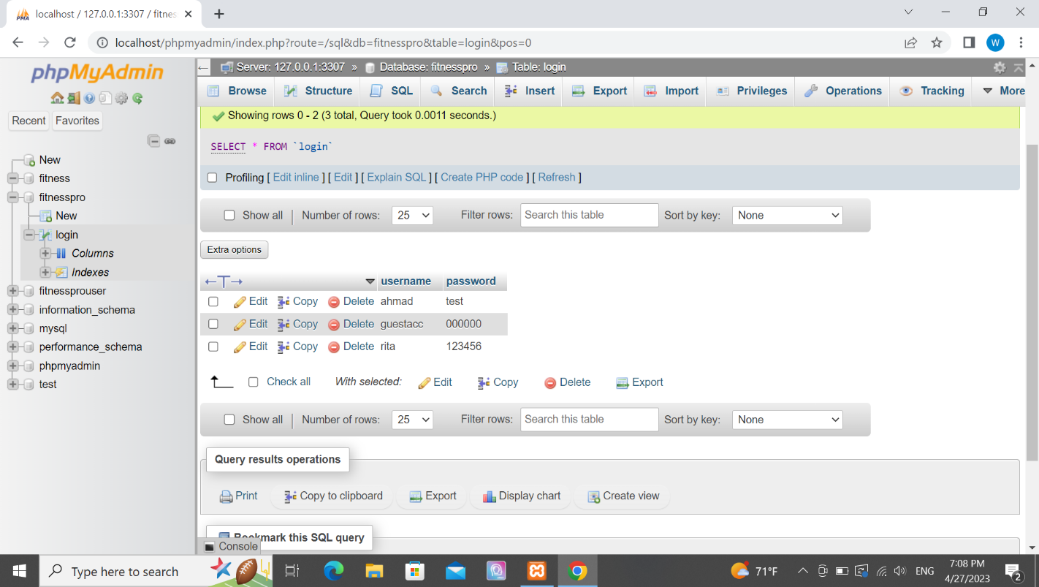

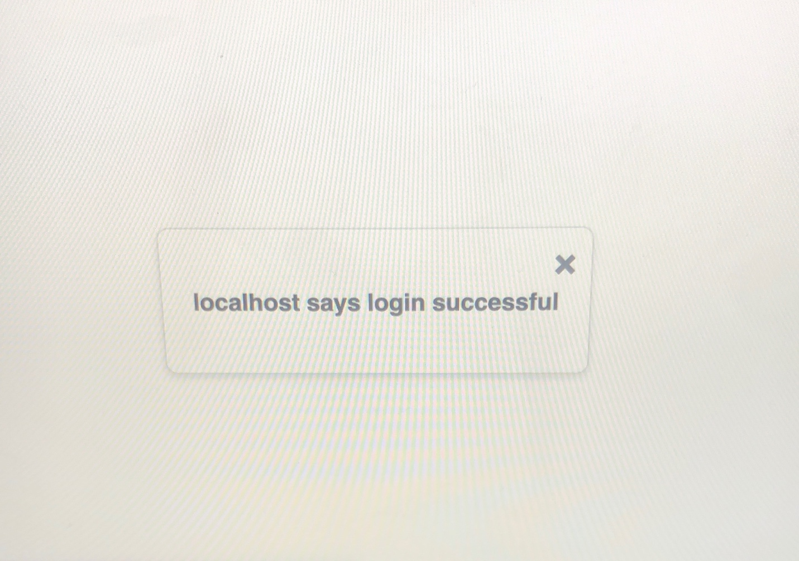

**2) login unsuccessful**

Using same database as the one above we try now to enter anything that doesn’t exist in the database.

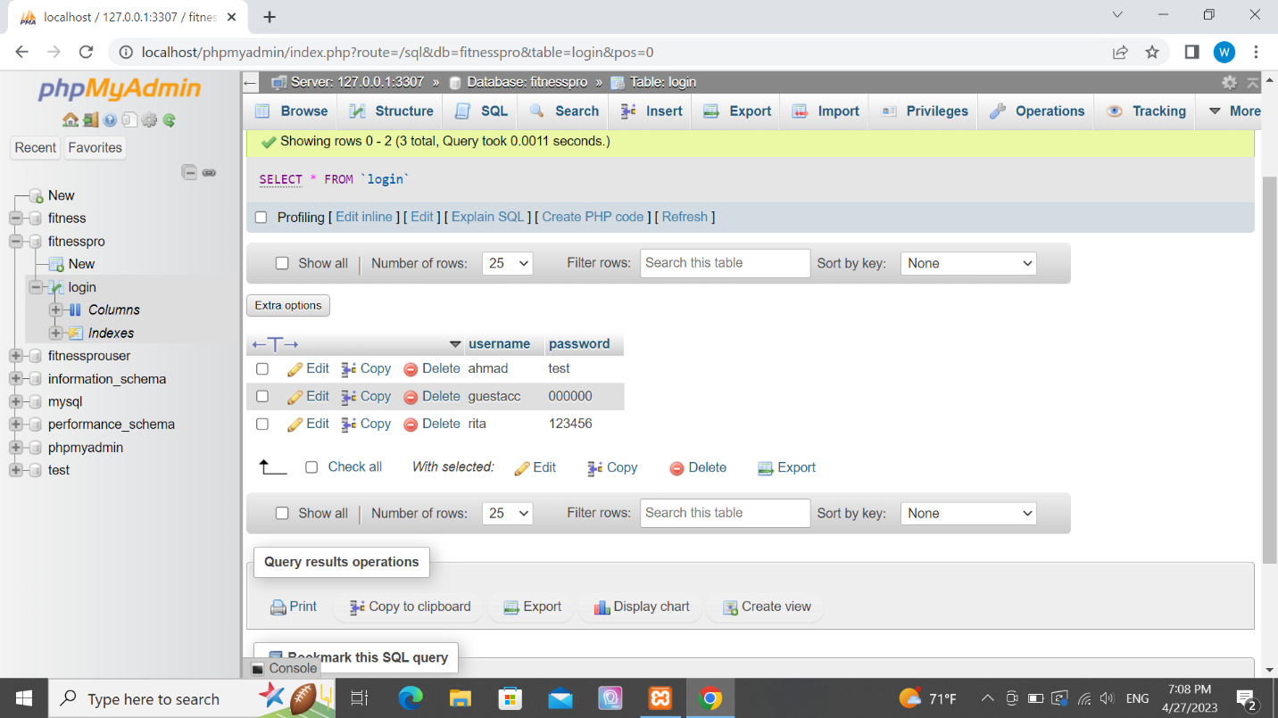

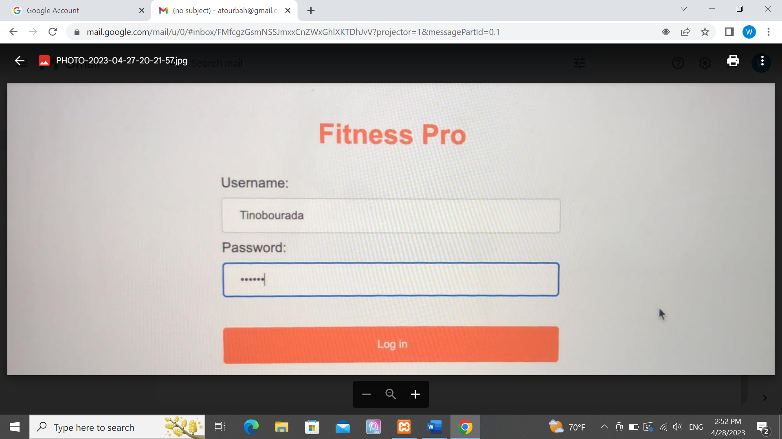

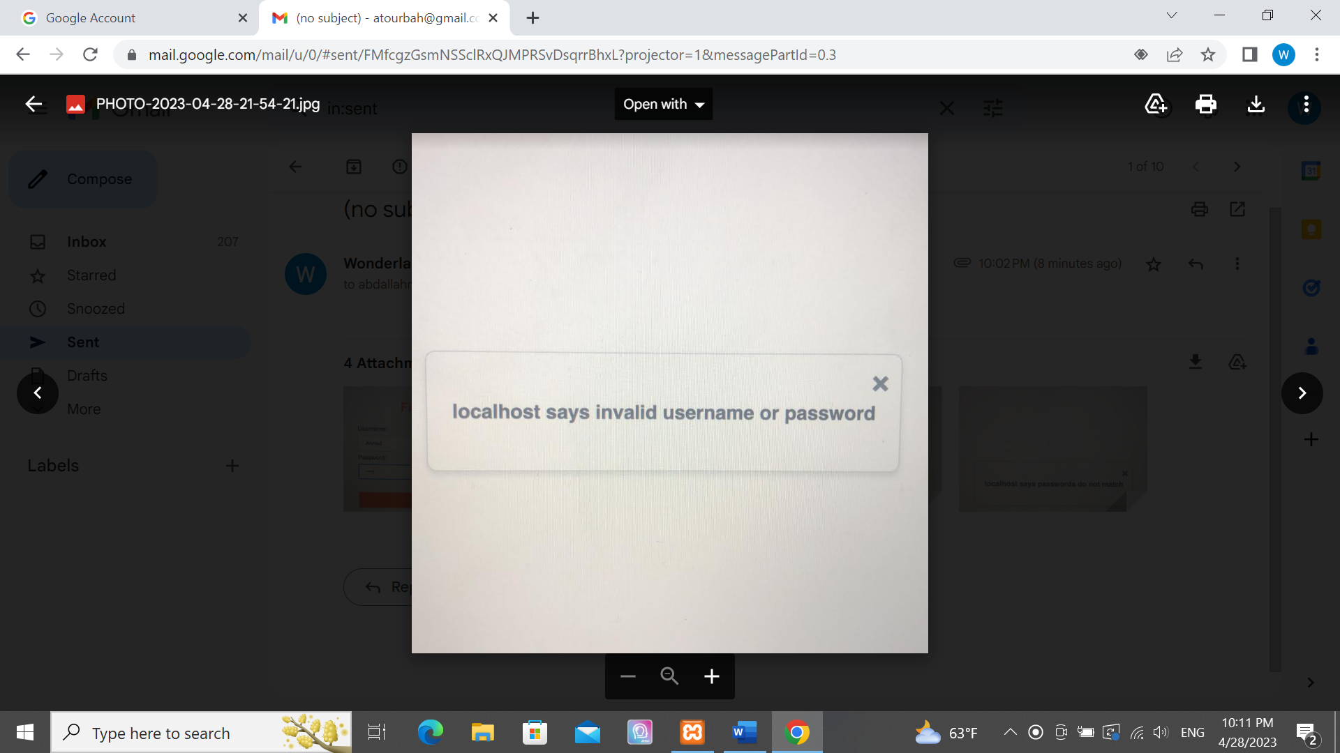

**Sign up:**

**1)signup successfully**

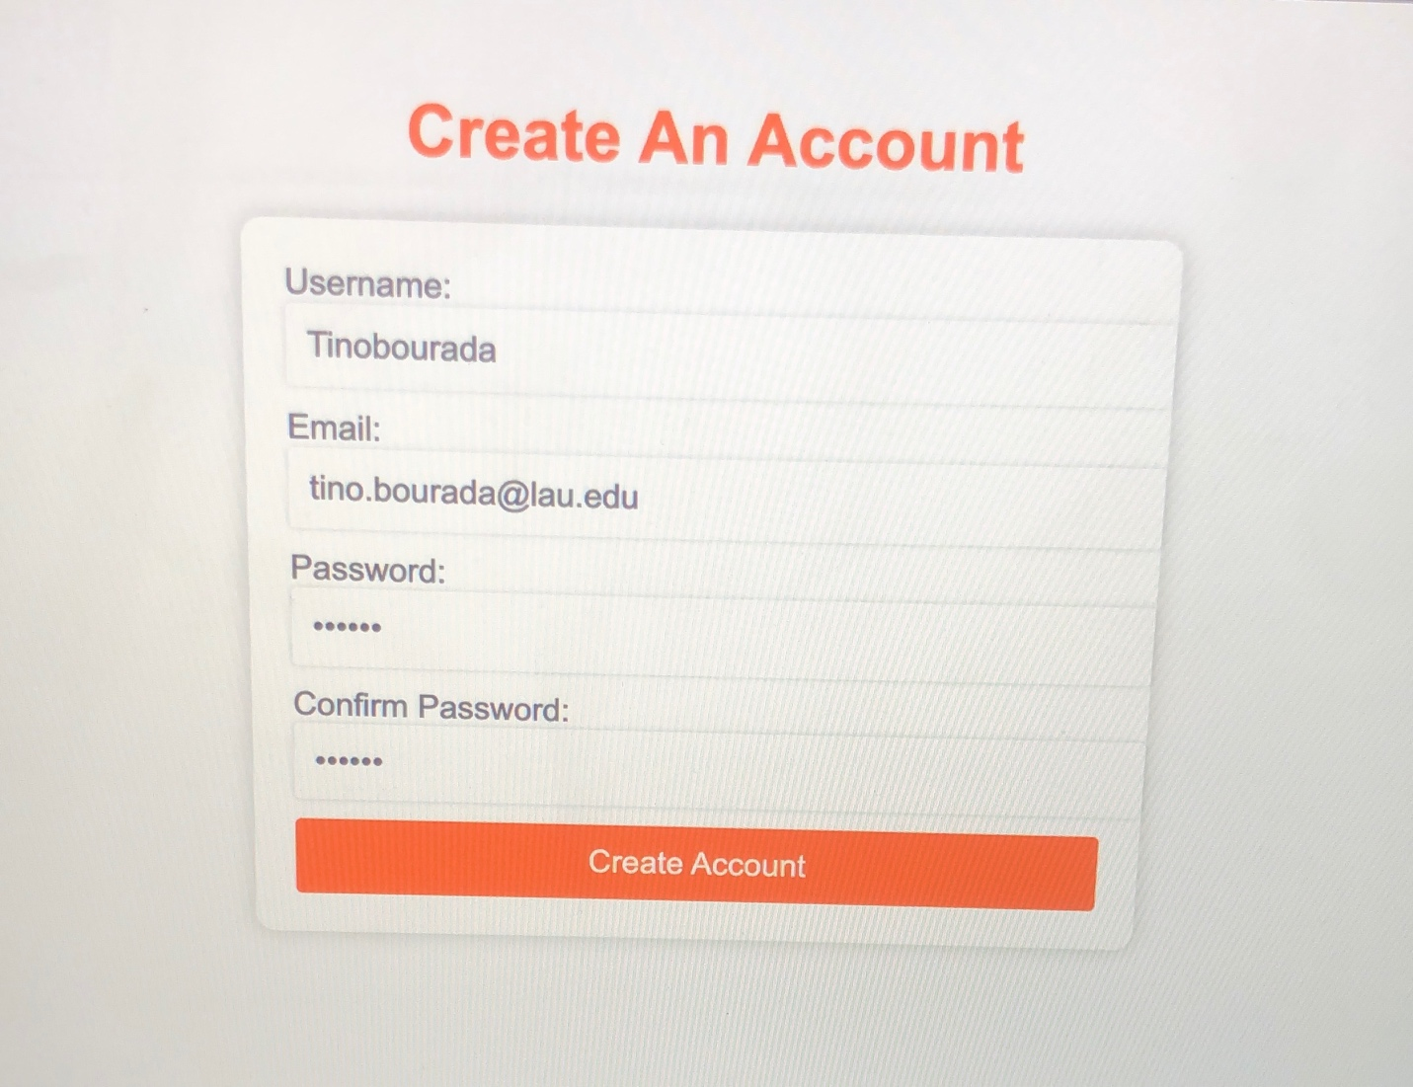

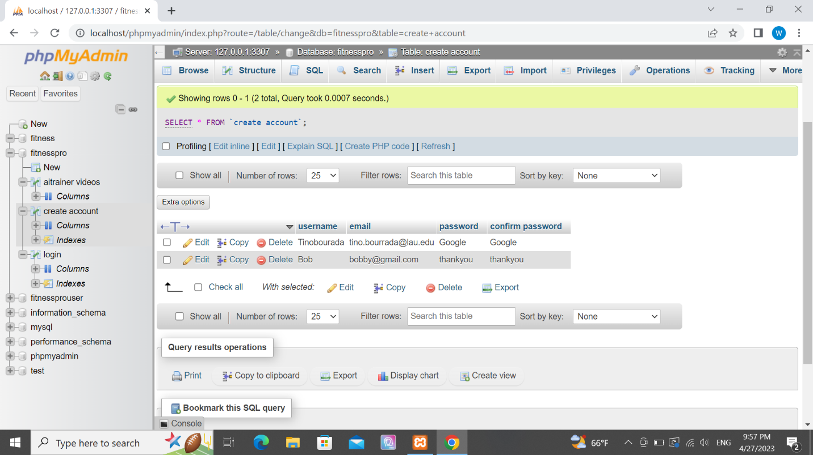

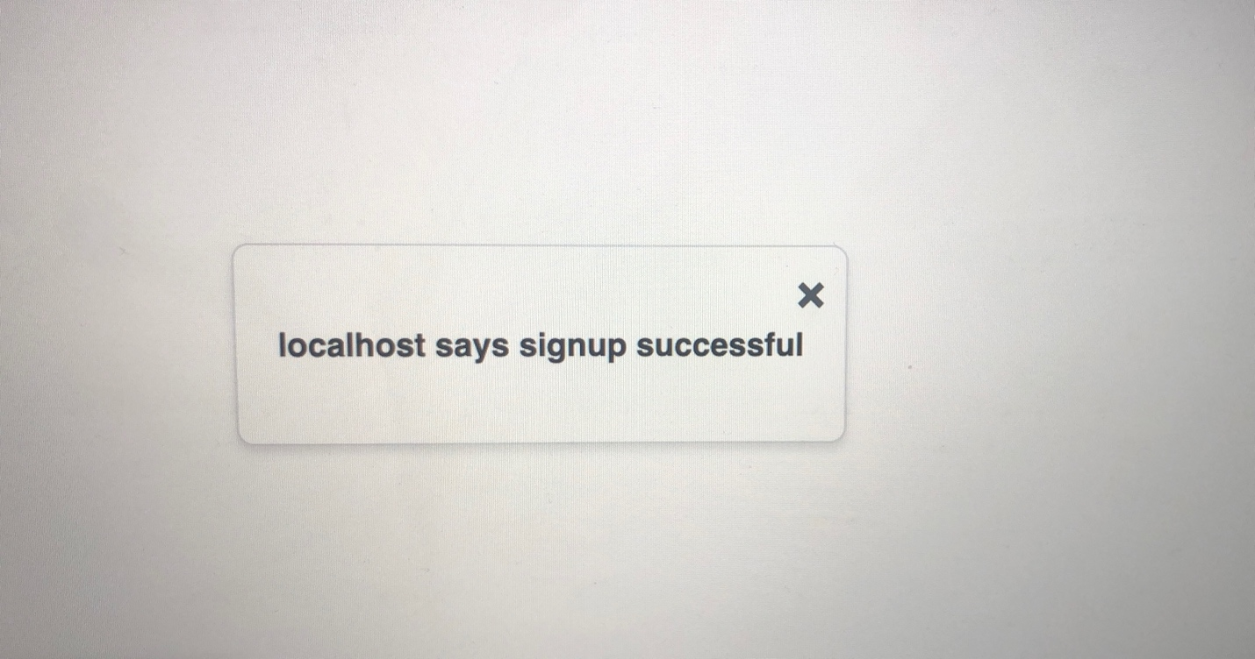

**2)Invalid username or password**

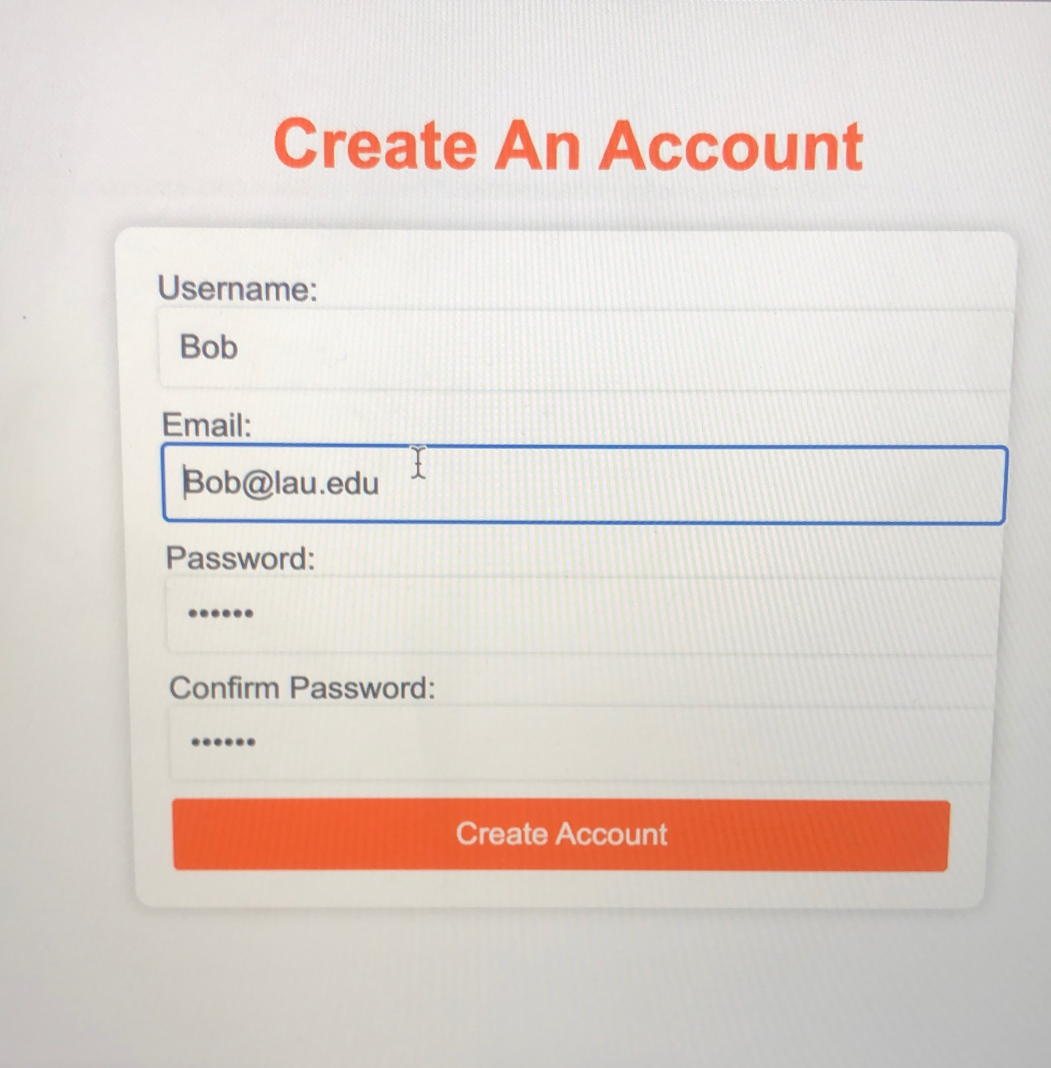





Since username is primary key we displayed this message on screen

it showed this message because someone using the username display already exist in the database and it is unique in this web application since username is a primary key.

**3) passwords do not match**

This happens when the 2 fields password and confirm passwords do not match with each other in this case we used password and confirm password different clear since one is length 4 and the other is length 5 aside from the program making sure it is matching.

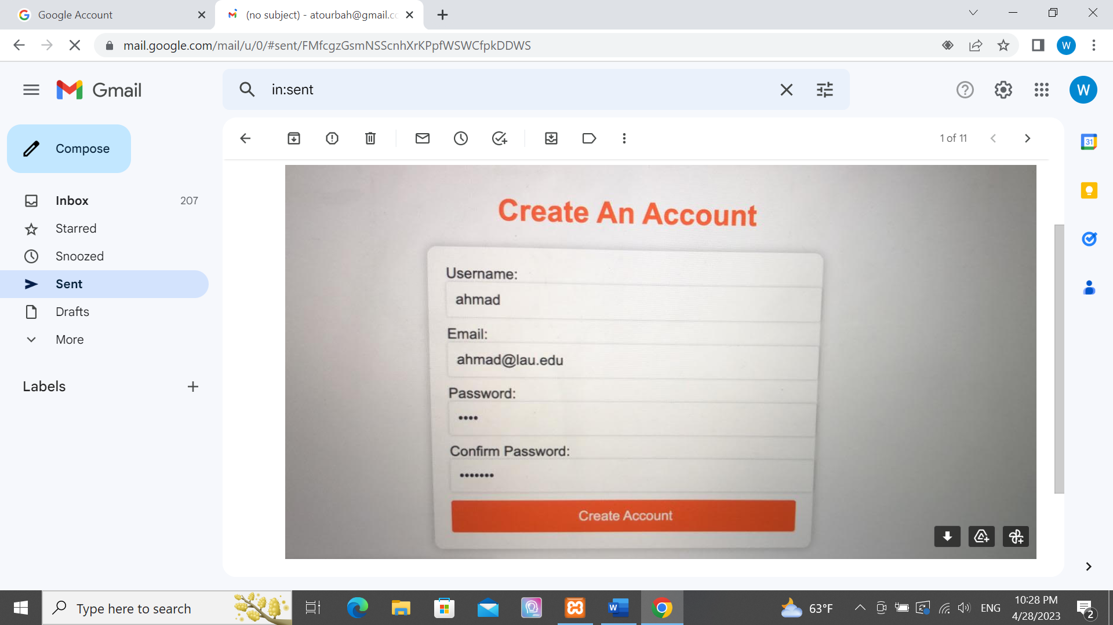

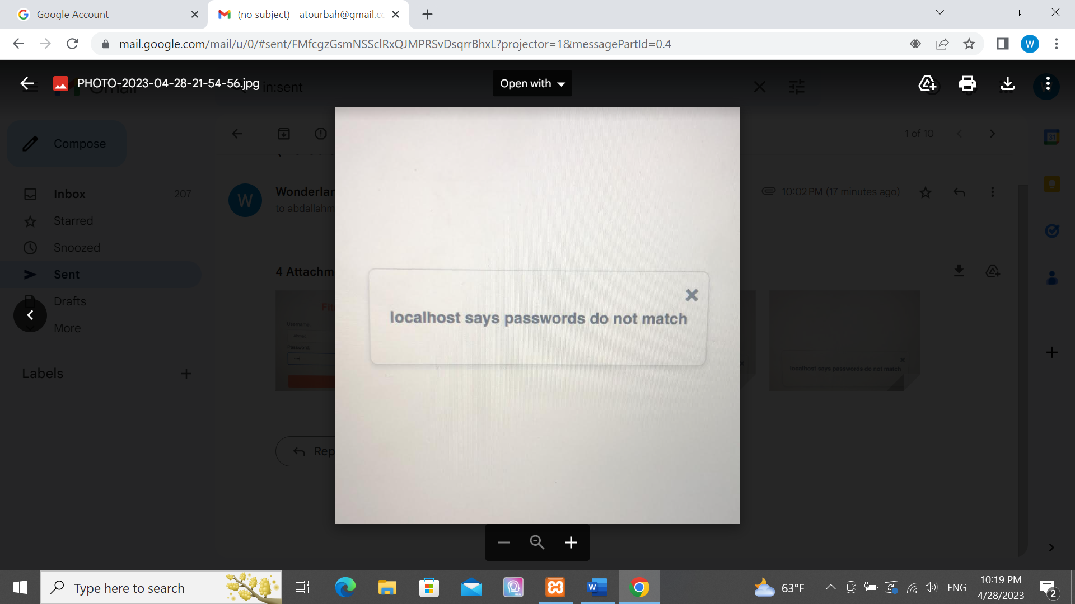

**Add Video:**

**1)video added**

After adding video with id=3





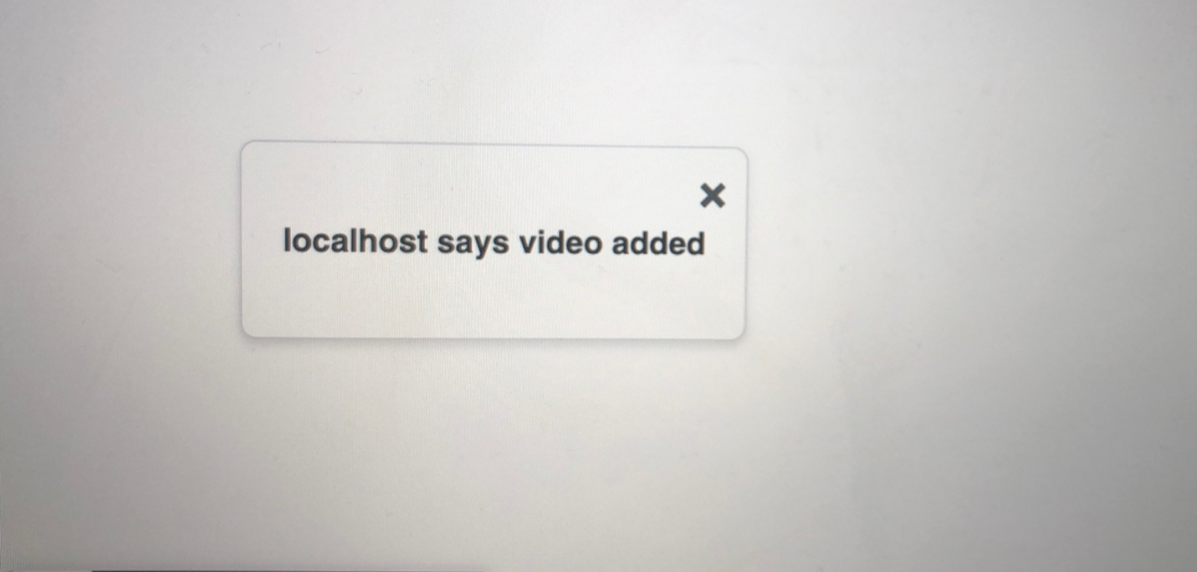

**Delete Video:**

**1)video deleted**

After deleting video with id=2

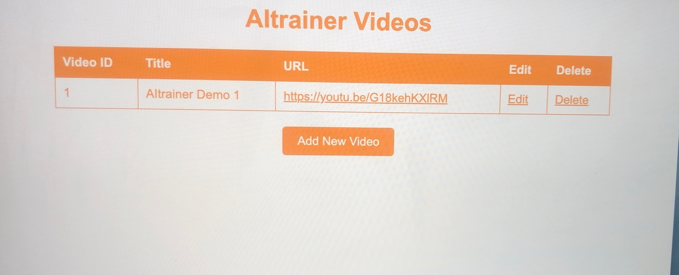



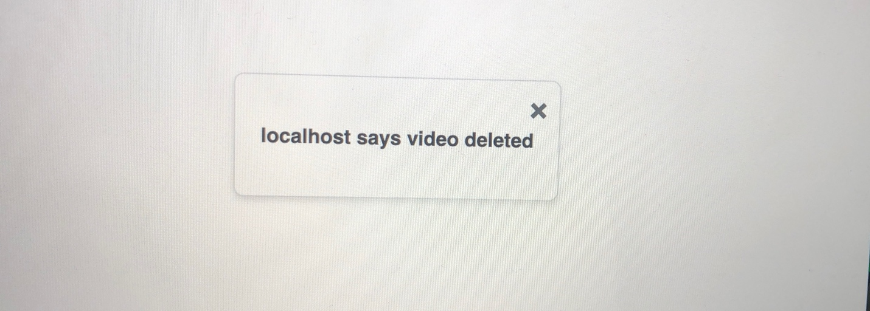

**Conclusion:**

To conclude and to summarize the implementation of the system that we detailed the focus was on how testing the changes enhanced the software and experiencing users expectations upon pressing signup or login using PHP, HTML, MYSQL and a little JavaScript in our software.

In addition we showed 2 use cases of FitnessPro greeting users with login or create account pages where upon login user and password should match one element of the list existing in the database. And upon create account testing the existence of the same username and the matching between password field and confirm password field. As for admin we implemented and tested 2 use cases with adding and deleting videos where things are less tricky there.